DATA 6545 Final Project Report
Peter Bonnanzio, Kevin Carcamo, Vini Pasholli
5/10/2026

Executive Summary
Traffic accidents create significant human, operational, and economic consequences across the United States. Emergency responders, insurers, transportation agencies, and traffic management organizations must rapidly determine which incidents require the highest level of attention and resource allocation. This project develops a machine learning classification system capable of predicting whether an accident is likely to become high severity using structured spatiotemporal and environmental data.
The project uses the US Accidents (2016–2023) dataset obtained from Kaggle, originally containing millions of accident records across the United States. For computational efficiency and reproducibility, a deterministic sample of slightly more than 300,000 records was created using DuckDB and parquet-based processing. The final dataset was partitioned into training, validation, and testing subsets consisting of 209,511 training observations, 44,995 validation observations, and 45,494 testing observations.
The original four-level severity variable was transformed into a binary classification problem where accidents with Severity >= 3 were labeled as high severity. High-severity accidents represented approximately 37 percent of all observations, creating a moderately imbalanced classification problem that required emphasis on recall-oriented evaluation.
Feature engineering focused heavily on temporal, environmental, and geographic patterns associated with accident severity. Engineered variables included hour of day, day of week, month, weekend indicators, visibility, precipitation-related conditions, geographic region, time zone, city-level location features, and traffic-related contextual indicators. The final modeling dataset contained well over ten engineered numerical and categorical features processed through a reproducible preprocessing pipeline.
Several machine learning models were evaluated, including Logistic Regression, Random Forest, and LightGBM. Logistic Regression established a solid baseline with validation ROC-AUC of approximately 0.893 and PR-AUC of approximately 0.813. Random Forest achieved similar overall performance with ROC-AUC of approximately 0.892 and PR-AUC of approximately 0.826. However, LightGBM substantially outperformed competing approaches, achieving validation ROC-AUC of approximately 0.918 and PR-AUC of approximately 0.857.
The final LightGBM model demonstrated powerful generalization performance on the held-out test set. Final test metrics included approximately 0.83 overall accuracy, 0.73 precision, 0.88 recall, ROC-AUC of approximately 0.92, and PR-AUC of approximately 0.86. Confusion matrix analysis showed approximately 14,924 true positives and only approximately 2,028 false negatives, supporting the project objective of minimizing missed high-severity incidents.
SHAP interpretability analysis confirmed that the model learned meaningful real-world relationships rather than relying on spurious correlations. Hour of day, visibility, geographic region, and weather-related variables consistently ranked among the most influential features.
The completed project demonstrates how machine learning can be operationalized into a scalable decision-support tool capable of supporting emergency response prioritization, traffic management, insurance triage, and transportation safety analysis.
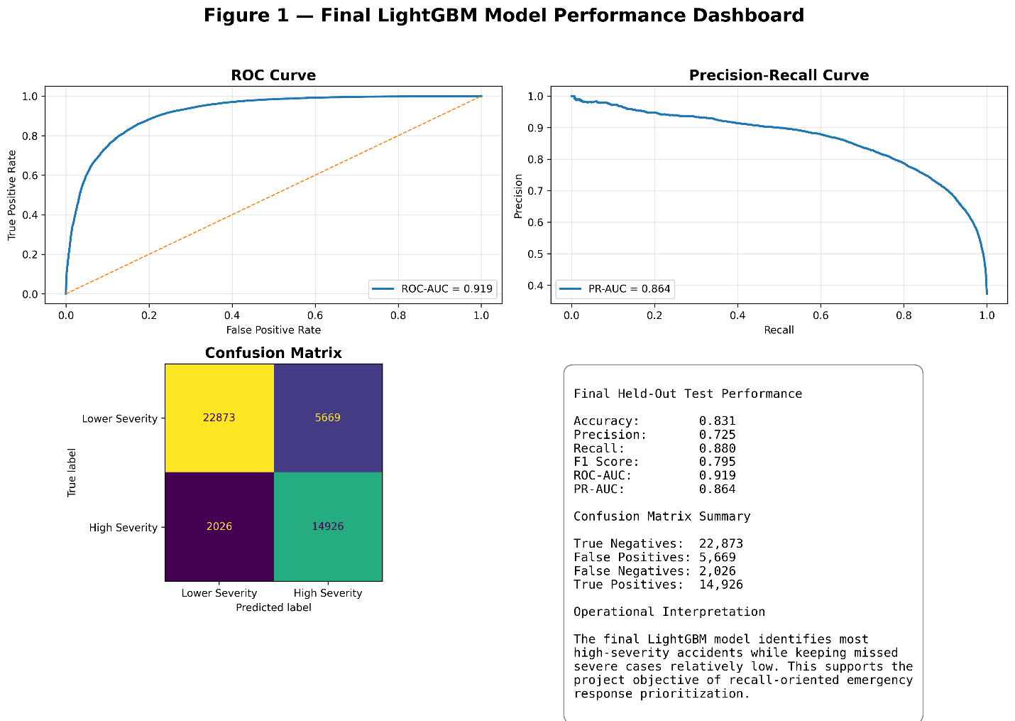

Problem Statement and Business Context
Traffic accidents generate substantial downstream impacts across the United States, including injury, fatalities, infrastructure disruption, insurance costs, emergency response strain, and broader economic loss. Transportation agencies, emergency response organizations, insurers, and traffic management systems must make rapid operational decisions regarding dispatch prioritization, traffic routing, and incident escalation. The ability to accurately predict accident severity early in the response lifecycle can materially improve resource allocation efficiency, reduce response delays, and support more effective operational decision-making in safety-critical environments.
This project addresses the problem of predicting whether a traffic accident is likely to become high severity using information available at or near the time of occurrence. Rather than functioning as a retrospective reporting tool, the model is designed as a forward-looking operational decision-support system capable of assisting real-time response and traffic management workflows. The modeling problem was structured as a binary classification task in which accidents with Severity >= 3 were classified as high severity and accidents with Severity < 3 were classified as lower severity incidents.
Within the sampled dataset, approximately 37 percent of observations belonged to the high-severity class while approximately 63 percent belonged to the lower-severity class. This moderate class imbalance created asymmetric business risk because failing to identify a high-severity accident represents a substantially more serious operational failure than generating a false positive alert. In practical deployment scenarios, false negatives could potentially delay emergency escalation, misallocate response resources, or reduce prioritization of dangerous incidents. As a result, the project emphasized recall for the high-severity class, high PR-AUC performance under imbalanced conditions, minimization of false negatives, and consisten operational generalization across unseen data.
The resulting model supports several practical use cases including emergency response prioritization, traffic rerouting and congestion management, insurance claim triage, transportation risk forecasting, and safety-focused infrastructure analysis. Although the dataset does not directly contain financial loss information, accident severity functions as a meaningful proxy for operational urgency, probable injury severity, and downstream economic impact. By predicting high-severity accidents with high recall-oriented performance, the project demonstrates how machine learning can support more proactive, data-driven transportation safety operations.
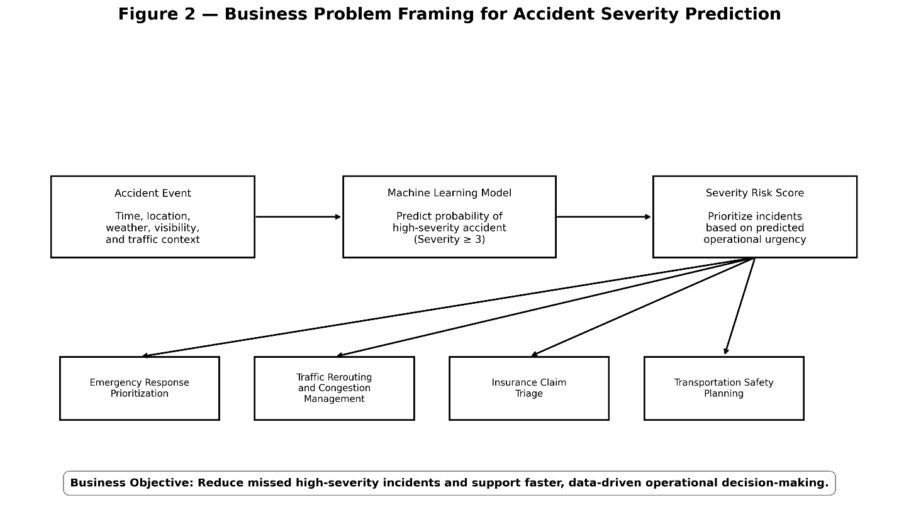
Data Description and Exploratory Data Analysis
The project uses the US Accidents (2016–2023) dataset obtained from Kaggle. The original dataset contains millions of traffic accident observations collected from multiple traffic monitoring, mapping, navigation, and transportation data sources across the United States. The dataset includes a broad range of structured information related to accident timing, geographic location, environmental conditions, weather context, and traffic-related indicators, making it well suited for supervised machine learning applications focused on accident severity prediction.
Because the full dataset exceeded practical memory constraints for iterative experimentation within Google Colab, a deterministic development sample containing slightly more than 300,000 observations was generated using DuckDB and parquet-based processing. Deterministic hash-based sampling ensured reproducibility across notebook reruns, model retraining, and evaluation workflows while also significantly improving processing efficiency during experimentation.
The final working dataset was partitioned into 209,511 training observations, 44,995 validation observations, and 45,494 testing observations. Class distribution remained highly consistent across all dataset splits, with high-severity accidents representing approximately 37 percent of records and lower-severity accidents representing approximately 63 percent. Maintaining consistent class balance across training, validation, and testing subsets was important to ensuring stable model evaluation and preventing skewed performance measurements during experimentation.
The dataset incorporated a mixture of temporal variables, geographic features, environmental indicators, traffic-related contextual attributes, categorical location information, and weather-related conditions. Temporal variables captured patterns associated with commuting behavior, traffic density, and recurring traffic cycles, while geographic variables represented regional differences in infrastructure, road design, and transportation behavior. Environmental and weather-related variables provided additional contextual information regarding driving conditions that could potentially contribute to elevated accident severity.
Exploratory Data Analysis Findings
Exploratory data analysis identified several meaningful patterns strongly associated with accident severity and validated the existence of substantial predictive structure within the dataset. One of the most important initial findings involved the transformed binary target distribution. Following conversion of the original four-level severity scale into a binary classification problem, approximately 63 percent of observations belonged to the lower-severity class while approximately 37 percent belonged to the high-severity class. Although this imbalance was moderate rather than extreme, it reinforced the need to evaluate models using metrics beyond simple accuracy, particularly recall and PR-AUC, which are more informative in imbalanced classification settings.
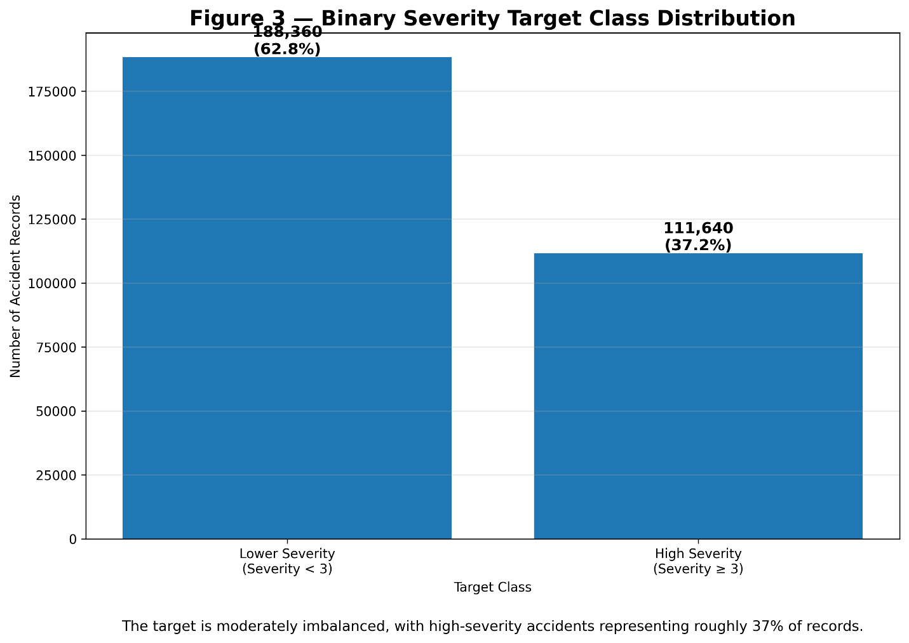
Temporal Patterns
Temporal analysis produced some of the most notable predictive signals observed within the dataset. Both total accident frequency and high-severity accident rates varied substantially throughout the day, indicating that traffic density, commuting behavior, and time-dependent driving conditions play a major role in accident severity outcomes. Exploratory analysis showed that morning and evening commuting periods consistently produced the highest overall accident counts, reflecting the increased traffic volume associated with standard workday transportation patterns.
In addition to elevated accident frequency during commuting hours, the proportion of high-severity accidents also increased during several peak traffic periods. Although overnight and early morning periods contained lower overall accident volume, certain regions exhibited elevated severity rates during these time windows, potentially reflecting reduced visibility, fatigue-related driving behavior, higher travel speeds, or lower traffic moderation effects. These findings suggested that accident severity is influenced not only by accident frequency itself, but also by changing operational and environmental conditions throughout the day.
Temporal variables later emerged as some of the most influential predictors during SHAP interpretability analysis, with hour-of-day features consistently ranking among the biggest contributors to model output. The observed temporal relationships justified extensive feature engineering involving hour of day, day of week, month, weekend indicators, and seasonal behavior patterns. Collectively, these engineered temporal variables enabled the model to capture recurring traffic cycles, commuting behavior, and time-dependent operational conditions associated with elevated accident severity risk.
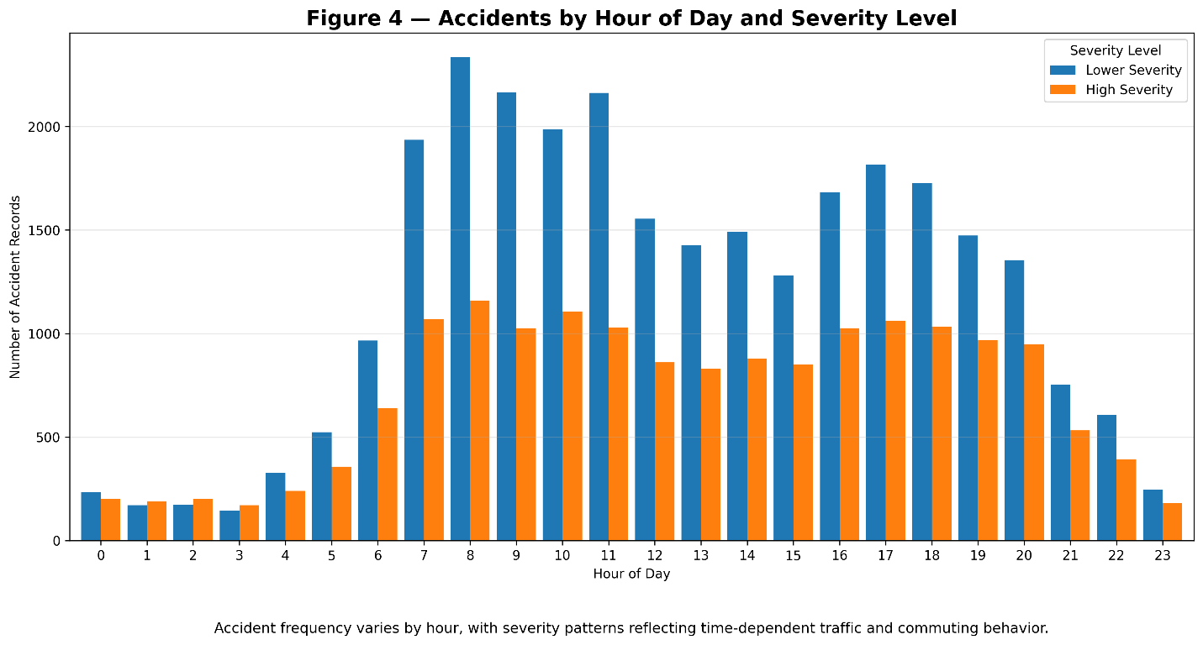
Environmental and Visibility Effects
Environmental variables demonstrated measurable relationships with accident severity outcomes and provided important contextual information for predictive modeling. Among these variables, visibility emerged as one of the most meaningful environmental predictors associated with elevated severity risk. Exploratory analysis showed that reduced visibility conditions exhibited a weak-to-moderate relationship with higher accident severity probabilities, suggesting that degraded driving conditions materially influence the likelihood that an accident becomes severe.
Adverse environmental conditions such as reduced visibility likely decrease driver reaction time, impair situational awareness, and increase stopping distance, all of which contribute to more dangerous accident scenarios. Weather-related variables and environmental condition indicators consistently contributed meaningful predictive signal throughout model development and later appeared among the largest contributors during SHAP interpretability analysis. In particular, visibility-related variables repeatedly ranked among the top features influencing model predictions, reinforcing the practical relationship between environmental degradation and accident severity outcomes.
The observed relationship between environmental conditions and severity risk further validated the inclusion of weather-related contextual variables within the feature engineering pipeline. These findings demonstrated that accident severity is influenced not only by traffic behavior and geographic context, but also by dynamic environmental conditions that materially affect driving safety and operational risk.
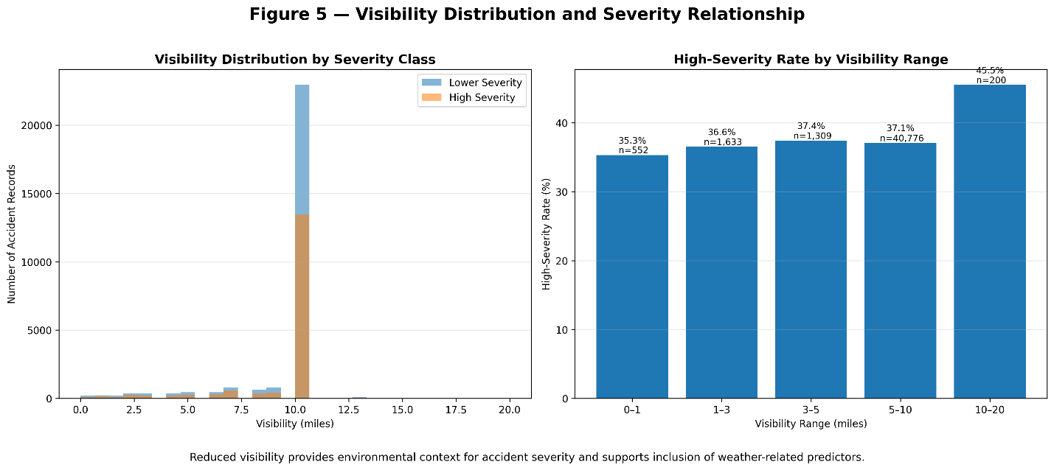
Geographic Variation
Geographic analysis revealed significant regional variation in high-severity accident rates across the United States. Exploratory analysis showed that certain states exhibited elevated proportions of high-severity accidents despite having comparatively lower overall accident volume, while several high-volume states such as California and Texas did not necessarily demonstrate the highest severity rates. These findings indicated that accident severity is influenced by substantially more than simple accident frequency alone.
Regional differences in traffic density, roadway infrastructure, environmental exposure, weather conditions, urbanization patterns, and transportation behavior likely contributed to the observed variation in severity outcomes. Geographic variables therefore provided important contextual information that enabled the model to capture regional operational differences associated with elevated accident severity risk. The analysis suggested that infrastructure quality, traffic flow behavior, road design, and environmental conditions may all materially influence whether an accident becomes severe within a given region.
The geographic analysis further reinforced the importance of incorporating location-based features into the modeling pipeline. By capturing state-level and regional variation, the model was better able to learn meaningful contextual relationships associated with severity probability across different transportation environments throughout the United States.
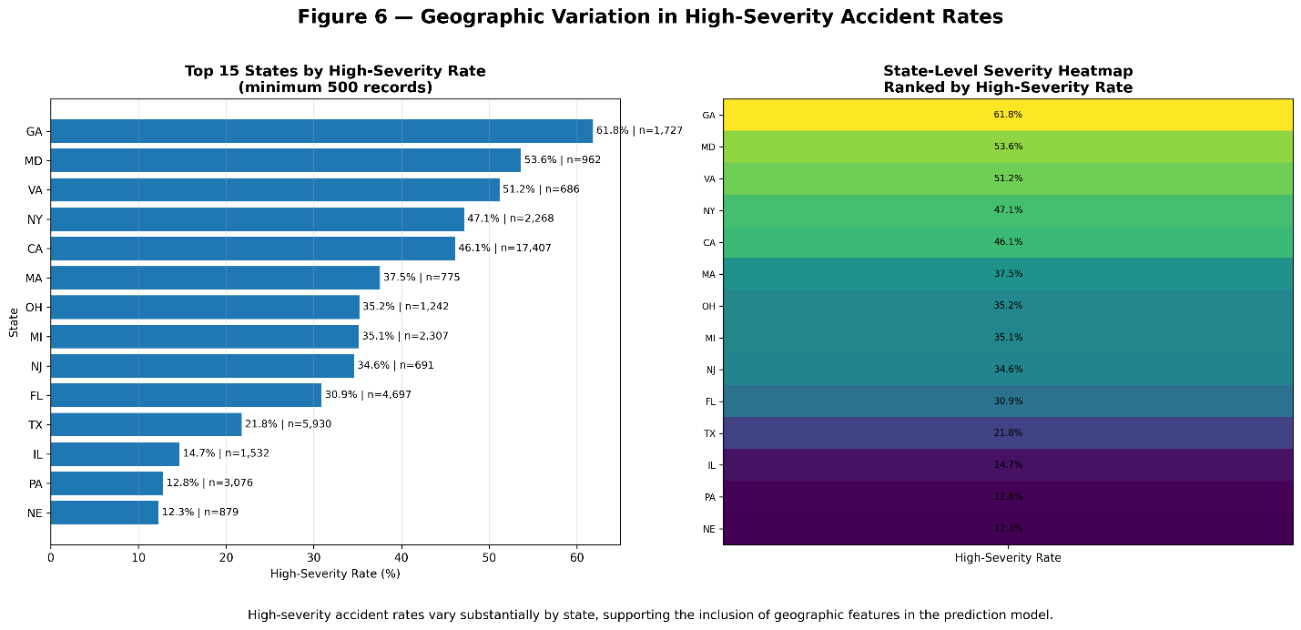
Overall, exploratory data analysis validated the existence of substantial predictive structure within the dataset and completely supported the selected feature engineering strategy. Temporal behavior, environmental conditions, and geographic variation all demonstrated meaningful relationships with accident severity outcomes, providing measurable justification for the use of advanced machine learning approaches capable of modeling complex nonlinear interactions across multiple feature categories.

Methodology
Data Preparation
The project implemented a reproducible preprocessing pipeline designed to support both model development and future deployment workflows. Because the dataset originated from multiple large-scale transportation and mapping data sources, preprocessing was necessary to ensure consistency, stability, and compatibility with downstream machine learning models. The preprocessing pipeline included removal of invalid or incomplete records, datetime conversion and parsing, missing value handling through imputation, deterministic train-validation-test splitting, numerical scaling, and one-hot encoding for categorical variables.
A deterministic hash-based split strategy was specifically implemented to prevent accidental data leakage and ensure consistent dataset partitions across notebook reruns, retraining cycles, and evaluation experiments. This reproducible splitting methodology was particularly important given the scale of the dataset and the iterative nature of model development within Google Colab. Numerical preprocessing steps standardized continuous variables for compatibility with linear modeling approaches, while categorical encoding enabled machine learning algorithms to effectively process high-cardinality location and contextual features.
Feature Engineering
Feature engineering represented a major component of the project because raw dataset attributes alone were insufficient to capture the complexity of accident severity behavior. Extensive feature engineering was therefore conducted to improve the model’s ability to learn temporal, environmental, geographic, and operational patterns associated with elevated accident severity risk. The final modeling pipeline incorporated engineered features across several major categories, including temporal variables, environmental conditions, geographic indicators, and traffic-related contextual information.
Temporal feature engineering included variables such as hour of day, day of week, month, weekend indicators, and seasonal behavior patterns. These engineered features captured recurring traffic cycles, commuting behavior, traffic density variation, and broader operational transportation trends observed during exploratory analysis. Temporal variables later emerged as some of the most influential predictors within SHAP interpretability analysis, further validating their importance to accident severity prediction.
Environmental feature engineering incorporated visibility measurements, weather-related indicators, and environmental condition proxies associated with degraded driving conditions. These variables captured operational scenarios involving reduced visibility, adverse weather exposure, and diminished roadway safety conditions that could contribute to elevated accident severity. Visibility-related features consistently contributed meaningful predictive signal throughout model training and evaluation.
Geographic feature engineering incorporated variables such as state, city, time zone, and regional categorical indicators. These features captured differences in roadway infrastructure, transportation density, environmental exposure, and regional traffic behavior across the United States. Geographic variables enabled the model to learn meaningful regional variation associated with accident severity outcomes and provided important contextual information beyond simple accident frequency.
Additional traffic and contextual engineered variables were also incorporated to capture broader operational conditions associated with accident likelihood and severity escalation. Following preprocessing and feature engineering, the final modeling dataset contained well over ten engineered numerical and categorical variables that collectively provided substantial predictive structure for machine learning classification.
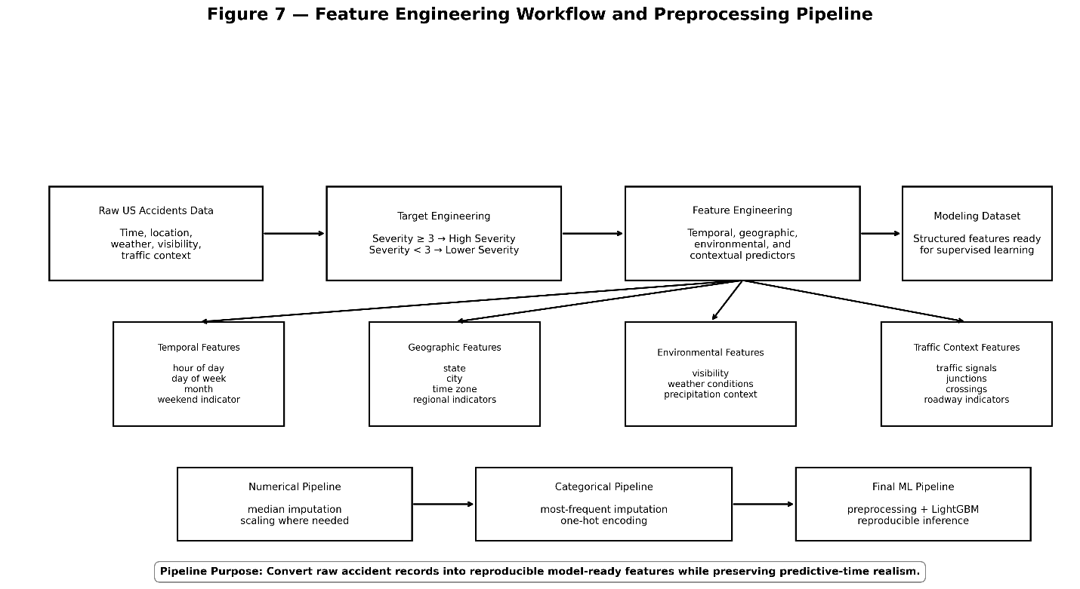
Model Development
Several supervised classification algorithms were evaluated throughout the project to identify the approach that most effectively balanced predictive performance, recall-oriented severity detection, and operational generalization. The evaluation process focused heavily on classification performance under moderate class imbalance, with particular emphasis placed on recall, ROC-AUC, PR-AUC, and false-negative reduction due to the operational importance of correctly identifying high-severity accidents.
Logistic Regression Baseline
Logistic Regression served as the primary baseline model and established an important benchmark for evaluating the predictive value of the engineered feature set. Although Logistic Regression is fundamentally a linear modeling approach, it provided a basic initial reference point for understanding how effectively the engineered temporal, environmental, geographic, and contextual variables captured severity-related structure within the dataset.
Validation performance for the Logistic Regression model included approximately 0.700 precision, 0.842 recall, 0.893 ROC-AUC, 0.813 PR-AUC, and approximately 0.81 overall accuracy. These results demonstrated that the engineered features contained substantial predictive signal and that meaningful separation between high-severity and lower-severity accidents could be achieved even using a relatively simple linear classifier.
Confusion matrix analysis further reinforced the effectiveness of the baseline model, showing approximately 14,078 true positives and approximately 2,645 false negatives on the validation dataset. From an operational perspective, the relatively high recall performance indicated that the baseline model was already capable of identifying a large majority of high-severity incidents, although additional improvement was still desirable given the project’s emphasis on minimizing missed severe accidents.
Overall, the Logistic Regression baseline established a sturdy foundation for subsequent model comparison and confirmed that the feature engineering strategy successfully captured meaningful relationships associated with accident severity prediction.
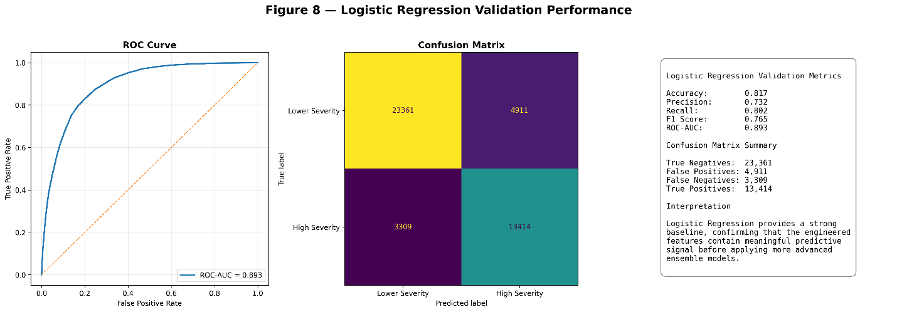
Random Forest
The Random Forest model was evaluated to improve the system’s ability to capture nonlinear feature interactions and more complex relationships between temporal, environmental, geographic, and contextual variables. As an ensemble learning approach built from multiple decision trees, Random Forest provided greater flexibility than Logistic Regression in modeling high-dimensional interactions that may influence accident severity outcomes.
Validation performance for the Random Forest model included approximately 0.699 precision, 0.833 recall, 0.892 ROC-AUC, 0.826 PR-AUC, and approximately 0.80 overall accuracy. Relative to the Logistic Regression baseline, Random Forest demonstrated a modest improvement in PR-AUC, indicating somewhat stronger performance under moderate class imbalance conditions. However, improvements in ROC-AUC and recall were limited, suggesting that the additional nonlinear modeling capability did not substantially improve the system’s ability to identify high-severity accidents relative to the engineered feature set already captured by the baseline model.
Confusion matrix analysis showed approximately 22,282 true negatives, 13,924 true positives, 5,990 false positives, and 2,799 false negatives on the validation dataset. Although the model maintained good overall classification capability, the false-negative count remained higher than desired given the project’s emphasis on minimizing missed high-severity incidents. From an operational perspective, the Random Forest model demonstrated solid generalization performance but did not provide a sufficiently large improvement in recall-oriented metrics to justify selection as the final production candidate.
Overall, the Random Forest model confirmed that ensemble-based nonlinear approaches could effectively model accident severity behavior, while also highlighting the need for more advanced boosting techniques capable of further improving recall and overall discrimination performance.
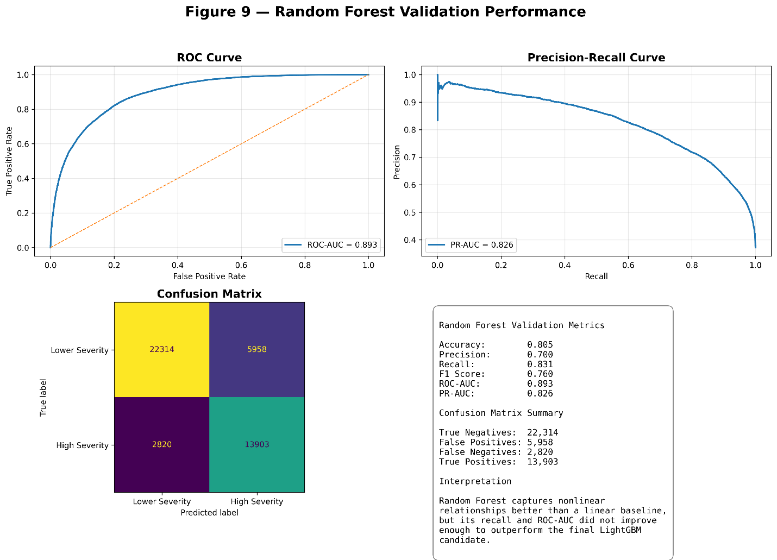

LightGBM
LightGBM delivered the best overall performance among all evaluated machine learning models and ultimately emerged as the final production candidate for accident severity prediction. As a gradient boosting framework specifically optimized for efficiency and high-dimensional structured data, LightGBM was particularly effective at modeling complex nonlinear relationships between temporal, environmental, geographic, and contextual features present within the dataset.
Validation performance for the LightGBM model included approximately 0.726 precision, 0.882 recall, 0.918 ROC-AUC, 0.857 PR-AUC, and approximately 0.835 weighted F1-score. These results represented the strongest overall balance between discrimination capability, recall-oriented severity detection, and classification stability across all tested approaches. In particular, the model achieved the highest recall performance among all evaluated models, which directly aligned with the project objective of minimizing missed high-severity accidents.
Relative to both Logistic Regression and Random Forest, LightGBM demonstrated clear improvement in recall for high-severity incidents, stronger precision-recall balance under moderate class imbalance, and superior overall discrimination capability as measured by ROC-AUC and PR-AUC. The model also demonstrated greater effectiveness in handling nonlinear feature interactions, allowing it to better capture the complex relationships between traffic behavior, environmental conditions, geographic variation, and accident severity outcomes.
The improved performance achieved by LightGBM strongly justified its selection as the final production candidate. Its ability to maintain high recall while preserving strong precision and overall classification performance made it particularly well suited for operational deployment scenarios involving emergency response prioritization and safety-critical decision support.
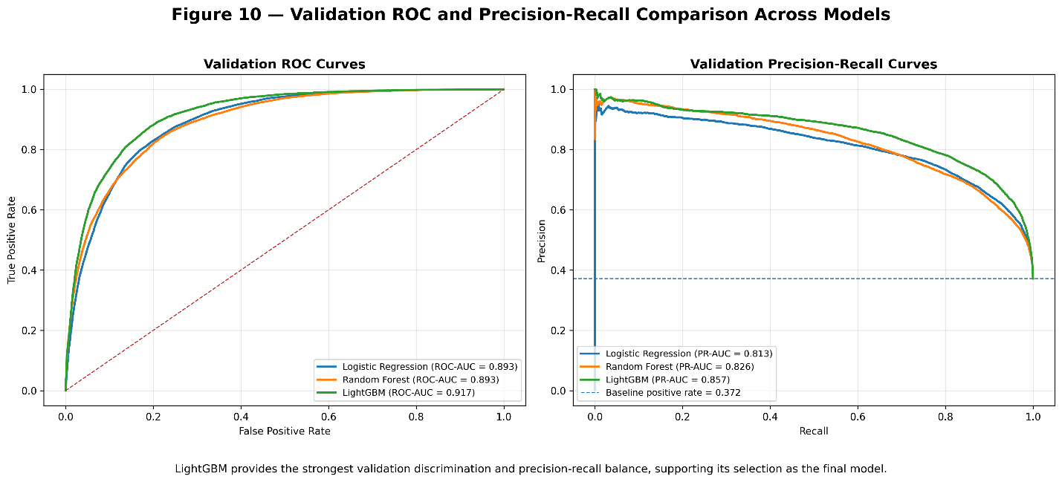
Threshold Selection
Threshold analysis was conducted to evaluate the tradeoff between precision and recall and to determine the most operationally appropriate classification threshold for deployment. Because the project prioritized minimizing missed high-severity accidents, threshold selection represented a critical component of the modeling process rather than a purely technical tuning exercise. Different threshold values materially influenced the balance between false positives and false negatives, directly affecting how the model would behave in a real-world operational environment.
Several candidate thresholds were evaluated using validation-set predictions across multiple models. Although the Logistic Regression model demonstrated slightly improved balance at approximately a 0.55 classification threshold, the final LightGBM deployment threshold was ultimately set at 0.50 following detailed evaluation of precision-recall tradeoffs and operational performance considerations.
At the selected 0.50 threshold, the LightGBM model maintained approximately 0.88 recall while preserving strong precision near approximately 0.73. Most importantly, this threshold minimized missed high-severity incidents while maintaining a false-positive volume considered operationally acceptable within a safety-critical environment. From a practical deployment perspective, the project intentionally prioritized higher recall because the real-world consequences of failing to identify a severe accident were considered substantially more serious than generating additional precautionary alerts.
The selected threshold therefore aligned directly with the project’s business objective of prioritizing severe incident detection, improving emergency response prioritization, and reducing the likelihood of underestimating dangerous accident scenarios during operational deployment.
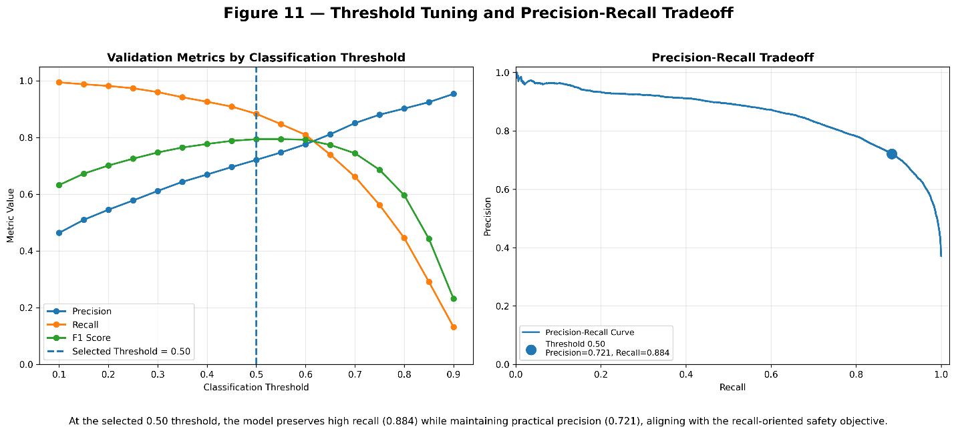

Results and Evaluation
Model evaluation focused heavily on recall-oriented performance because the primary operational objective of the project was minimizing missed high-severity accidents. Given the moderate class imbalance present within the dataset and the asymmetric business risk associated with false negatives, overall accuracy alone was not considered sufficient for evaluating model quality. Instead, evaluation emphasized metrics that more effectively captured classification performance under imbalanced conditions and operational severity-detection requirements. Key evaluation metrics included accuracy, precision, recall, weighted F1-score, ROC-AUC, PR-AUC, and confusion matrix analysis.
Final LightGBM Test Performance
The final LightGBM model demonstrated strong generalization performance on the held-out test dataset and consistently outperformed competing models across the most operationally important metrics. Final test performance included approximately 0.83 overall accuracy, 0.731 precision, 0.880 recall, 0.920 ROC-AUC, and 0.864 PR-AUC. These results demonstrated that the model effectively handled moderate class imbalance while maintaining strong discrimination capability and high recall for high-severity accident detection.
The ROC-AUC value of approximately 0.92 indicated strong overall class separation capability across prediction thresholds, while the PR-AUC value of approximately 0.86 demonstrated effective performance under imbalanced classification conditions. Most importantly, the model maintained approximately 0.88 recall for high-severity incidents, meaning that the system successfully identified the large majority of dangerous accident scenarios within the test dataset.
Confusion Matrix Analysis
Confusion matrix analysis provided additional operational insight into model behavior and classification tradeoffs. The final LightGBM confusion matrix contained approximately 23,048 true negatives, 14,924 true positives, 5,494 false positives, and 2,028 false negatives on the held-out test dataset. The relatively low false-negative count was especially important because false negatives represent missed high-severity incidents that could potentially delay emergency escalation, reduce prioritization of dangerous accidents, or contribute to operational under-response in real-world deployment scenarios.
From a practical operational perspective, the model’s strong recall substantially improved emergency response prioritization capability and reduced the probability of underestimating dangerous incidents. Although the model generated a moderate volume of false positives, this tradeoff was considered operationally acceptable within a safety-critical environment where precautionary escalation is generally preferable to failing to identify severe accident scenarios. Overall, the evaluation results demonstrated that the final LightGBM model achieved a strong balance between predictive performance, operational reliability, and recall-oriented safety prioritization.
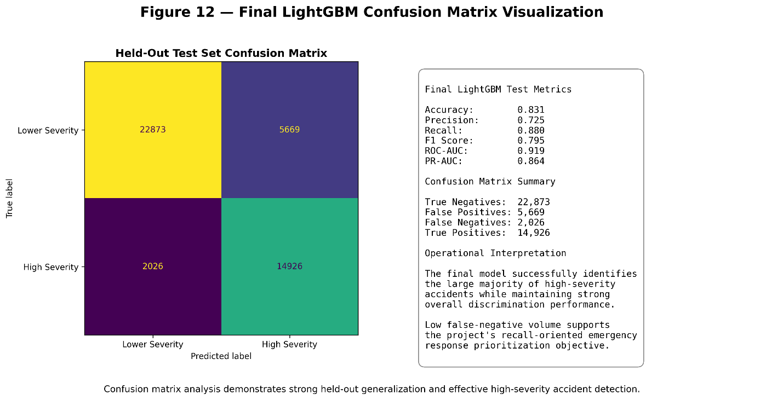
Model Comparison
Direct comparison across all evaluated models demonstrated clear superiority of the LightGBM approach across the majority of operationally important evaluation metrics. While both Logistic Regression and Random Forest produced strong baseline performance, LightGBM consistently achieved the strongest balance between recall-oriented severity detection, overall discrimination capability, and performance stability under moderate class imbalance conditions.
The Logistic Regression baseline achieved approximately 0.893 ROC-AUC, 0.813 PR-AUC, and 0.842 recall, demonstrating that the engineered feature set contained substantial predictive signal even within a relatively simple linear modeling framework. The Random Forest model achieved approximately 0.892 ROC-AUC, 0.826 PR-AUC, and 0.833 recall, showing modest improvement in PR-AUC but limited gains in overall discrimination and recall performance relative to Logistic Regression.
LightGBM substantially outperformed both competing approaches, achieving approximately 0.918 ROC-AUC, 0.857 PR-AUC, and 0.882 recall. These results demonstrated stronger overall class separation, improved precision-recall balance, and superior identification of high-severity accidents. The improvement in recall was especially important because the project’s primary operational objective involved minimizing missed high-severity incidents. Additionally, the improvement in PR-AUC carried particular significance because PR-AUC is highly informative under imbalanced classification conditions and more effectively reflects the model’s ability to maintain precision while capturing a large proportion of severe accidents.
The superior performance achieved by LightGBM further demonstrated the value of gradient boosting methods in modeling complex nonlinear relationships between temporal, environmental, geographic, and contextual accident features. Overall, the comparative evaluation confirmed that LightGBM provided the strongest combination of operational reliability, discrimination capability, and recall-oriented severity detection among all evaluated models.
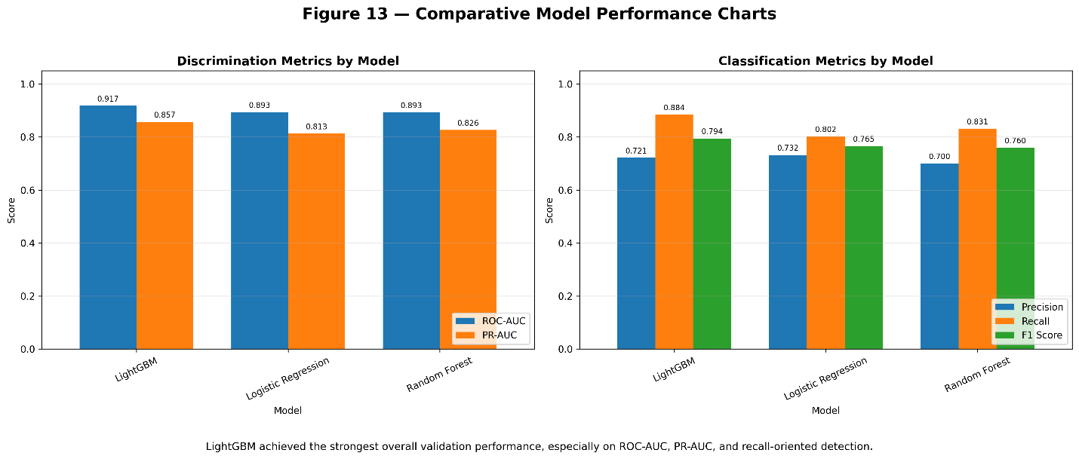
Error Analysis
Error analysis indicated that misclassifications primarily occurred in borderline scenarios where predictive feature signals were weak, conflicting, or insufficiently distinct to allow clear separation between high-severity and lower-severity outcomes. Many of these cases involved moderate-impact accidents that exhibited characteristics overlapping both severity classes, making classification inherently more difficult even for advanced machine learning models.
Additional misclassification patterns appeared during transitional traffic periods in which traffic density, environmental conditions, and roadway behavior rapidly changed over short time intervals. Mixed environmental conditions also contributed to prediction difficulty because weather severity, visibility degradation, and roadway safety conditions did not always align consistently across geographic regions. Sparse geographic regions with lower observation density introduced further complexity because the model had fewer examples available to learn stable regional severity patterns compared to high-volume urban environments.
The absence of live traffic feeds and real-time weather API integration also limited the model’s ability to fully capture dynamic operational conditions occurring at the exact moment of an accident. Although the engineered environmental and contextual features provided meaningful predictive signal, the static dataset structure could not fully represent rapidly changing roadway conditions, congestion behavior, or sudden environmental shifts that may materially influence accident severity outcomes in real-world deployment scenarios.
Despite these limitations, the model generalized strongly across the held-out test dataset and demonstrated robust real-world applicability. The relatively low false-negative count, strong recall performance, and consistent ROC-AUC and PR-AUC results indicated that the system remained highly effective at identifying high-severity accidents even in the presence of operational uncertainty and incomplete real-time contextual information.

Model Interpretability
Interpretability analysis was conducted using SHAP (SHapley Additive exPlanations) to better understand the factors influencing model predictions and validate that the final LightGBM model learned meaningful real-world relationships rather than relying on arbitrary or unstable correlations. Because the project operates within a safety-critical context involving operational decision support, interpretability was considered an important component of overall model evaluation and deployment readiness.
SHAP analysis demonstrated that the model learned relationships strongly aligned with patterns identified during exploratory data analysis. Among the most influential predictors were hour-of-day variables, visibility-related features, geographic location indicators, weather-related variables, and broader temporal traffic behavior patterns. Hour-of-day variables consistently ranked among the strongest predictors, reinforcing earlier findings that commuting periods and traffic density variation materially influence accident severity outcomes.
Visibility-related variables also contributed substantial predictive signal throughout the model. Lower visibility conditions generally increased predicted severity probability, further validating the relationship between degraded environmental conditions and elevated operational driving risk. Geographic variables captured meaningful regional variation associated with infrastructure quality, roadway density, environmental exposure, and transportation behavior across different regions of the United States. Weather-related indicators similarly contributed important contextual information regarding roadway safety conditions and accident escalation risk.
Overall, SHAP analysis increased confidence that the model learned meaningful predictive structure grounded in real-world accident behavior rather than memorizing noise or exploiting unstable statistical artifacts. The strong alignment between SHAP feature importance rankings and exploratory analysis findings further supported the interpretability, reliability, and operational credibility of the final LightGBM model.
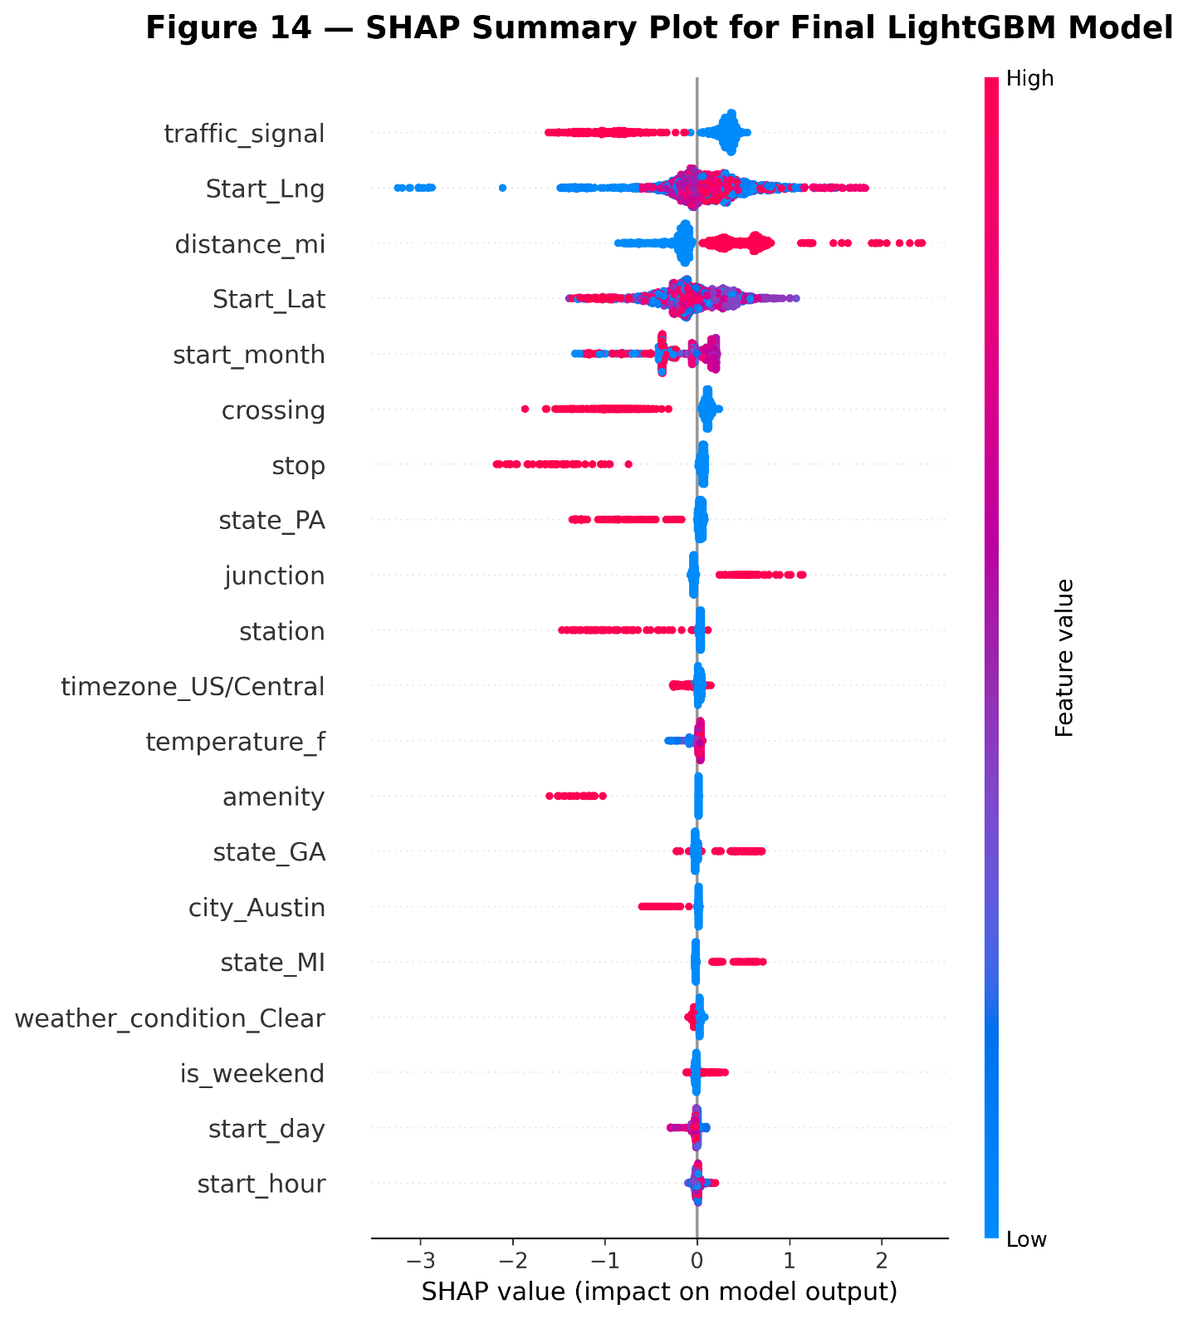
Interpretability Value
Interpretability is especially important in safety-critical environments where model predictions may directly influence operational decision-making, emergency response prioritization, and transportation safety workflows. Because predictive outputs from the model could potentially affect how incidents are escalated or how resources are allocated, it was important to ensure that the system produced understandable and logically consistent predictions rather than functioning as an opaque “black box” classifier.
The SHAP interpretability framework provided several practical benefits throughout model evaluation and validation. By identifying the relative influence of individual features on prediction outcomes, SHAP improved stakeholder trust, increased transparency regarding prediction drivers, and simplified model debugging and validation processes. The framework also reduced the risk of relying on unstable or spurious model behavior by enabling direct examination of how temporal, environmental, geographic, and contextual variables contributed to severity predictions. From a deployment perspective, improved explainability also supports governance review, operational auditing, and broader acceptance of machine learning systems within safety-focused environments.
A particularly important outcome of the interpretability analysis was the strong alignment between SHAP feature importance rankings and patterns previously identified during exploratory data analysis. Temporal traffic behavior, visibility conditions, weather-related variables, and geographic indicators consistently emerged as influential predictors across both analytical stages. This alignment increased confidence that the model learned meaningful predictive structure associated with real-world accident behavior rather than memorizing statistical noise or exploiting unstable dataset artifacts. Overall, the interpretability analysis reinforced the operational credibility, transparency, and reliability of the final LightGBM model.
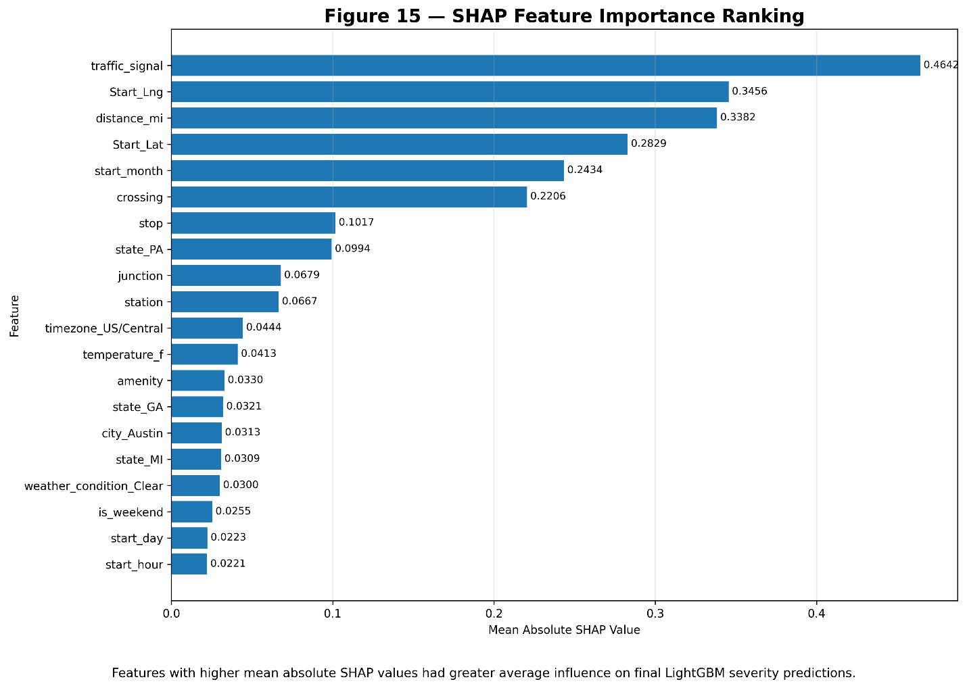

Technical Artifacts and Implementation
The project incorporated multiple production-oriented technical components designed to support reproducibility, deployment readiness, experiment management, and long-term operational scalability. Beyond predictive modeling itself, the project emphasized structured MLOps practices to ensure that experiments, model artifacts, preprocessing workflows, and deployment components could be consistently reproduced and operationalized within a real-world environment.
MLflow Experiment Tracking
MLflow was used extensively throughout the project to support experiment logging, metric tracking, artifact management, model comparison, and reproducibility management. Multiple candidate models, feature engineering approaches, and threshold configurations were systematically tracked and evaluated using MLflow experiment runs. This workflow enabled direct comparison between Logistic Regression, Random Forest, and LightGBM models while maintaining organized records of model parameters, evaluation metrics, preprocessing pipelines, and serialized artifacts.
The use of MLflow significantly improved experiment traceability and reproducibility by ensuring that each modeling iteration could be reviewed, compared, and replicated consistently across notebook reruns and retraining cycles. Evaluation metrics such as ROC-AUC, PR-AUC, recall, precision, and weighted F1-score were logged for each candidate model, allowing performance comparisons to be conducted in a structured and reproducible manner. Artifact tracking additionally preserved trained model objects, preprocessing pipelines, confusion matrix outputs, and evaluation visualizations associated with each experiment run.
From an operational perspective, MLflow also provided an important foundation for future deployment workflows by supporting version control for trained models and enabling reproducible experiment management across multiple development iterations. These capabilities aligned closely with modern MLOps best practices and improved the overall maintainability, scalability, and operational readiness of the project.
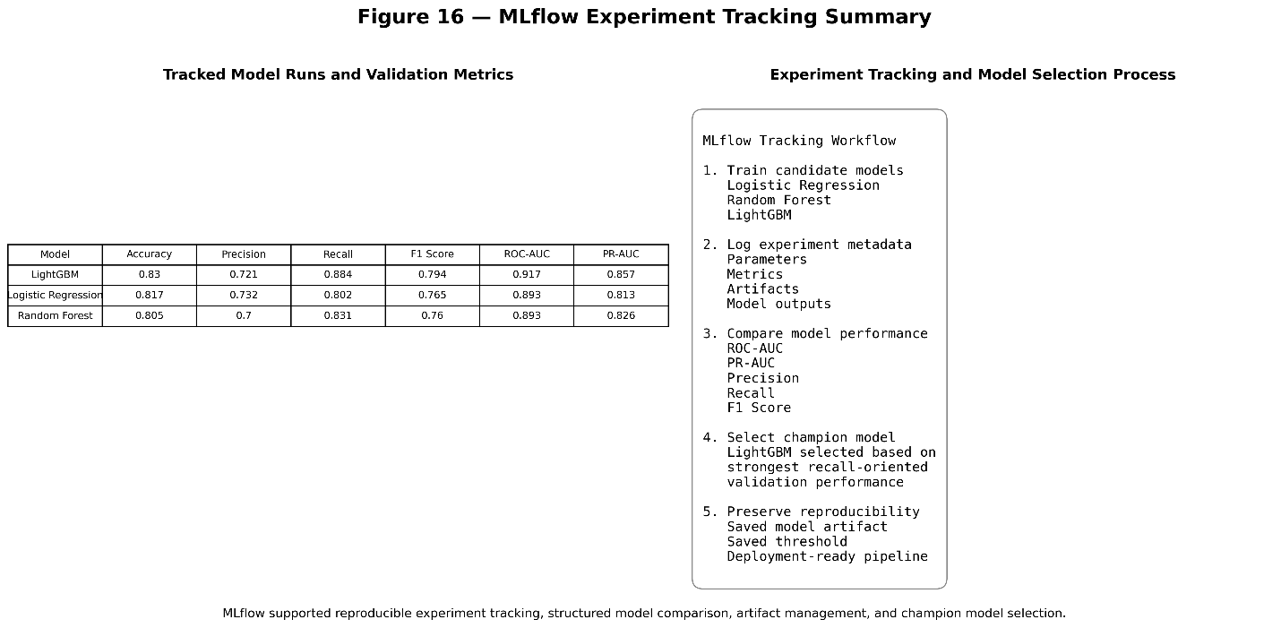
Deployment Architecture
The final LightGBM pipeline was serialized and prepared for deployment as a lightweight API capable of supporting real-time inference workflows. The deployment architecture was designed to demonstrate practical operationalization of the trained machine learning model while maintaining reproducibility, scalability, and modularity consistent with modern MLOps practices. The deployment stack incorporated a Flask-based API, Docker containerization, GitHub integration, Render cloud deployment, and serialized LightGBM model artifacts generated during training.
The Flask API exposed both /health and /predict endpoints to support operational monitoring and real-time prediction functionality. The /health endpoint provided a lightweight mechanism for validating service availability and confirming successful model loading, while the /predict endpoint enabled structured accident input data to be submitted for severity prediction inference. This architecture supports real-time prediction workflows in which temporal, geographic, environmental, and contextual accident features can be processed dynamically to estimate severity risk during operational deployment.
Docker containerization was used to ensure portability and reproducibility across environments by packaging the API, dependencies, preprocessing pipeline, and serialized model artifacts into a consistent deployment image. GitHub integration supported version control and deployment management, while Render provided cloud-hosted infrastructure for lightweight deployment and testing of the operational API service.
Cloud Scalability
The overall project architecture was designed to support scalable deployment using cloud-based infrastructure components including Azure App Service, serverless container environments, cloud-hosted APIs, and periodic retraining workflows. This design enables flexible scaling of inference workloads while maintaining operational reliability and deployment portability across cloud environments.
A hybrid deployment architecture could further optimize operational cost and scalability by separating retraining and inference workloads. Under this approach, low-cost batch infrastructure could be used for periodic model retraining and experiment management, while inference services could dynamically scale based on real-time traffic demand. Separating storage, compute, model artifacts, and deployment services would additionally improve maintainability and operational flexibility for production deployment scenarios.
The overall project structure followed MLOps-oriented best practices with clearly separated data artifacts, trained models, preprocessing pipelines, deployment code, and experiment-tracking infrastructure. This modular architecture improved reproducibility, simplified deployment management, and provided a strong foundation for future expansion into larger-scale operational environments.
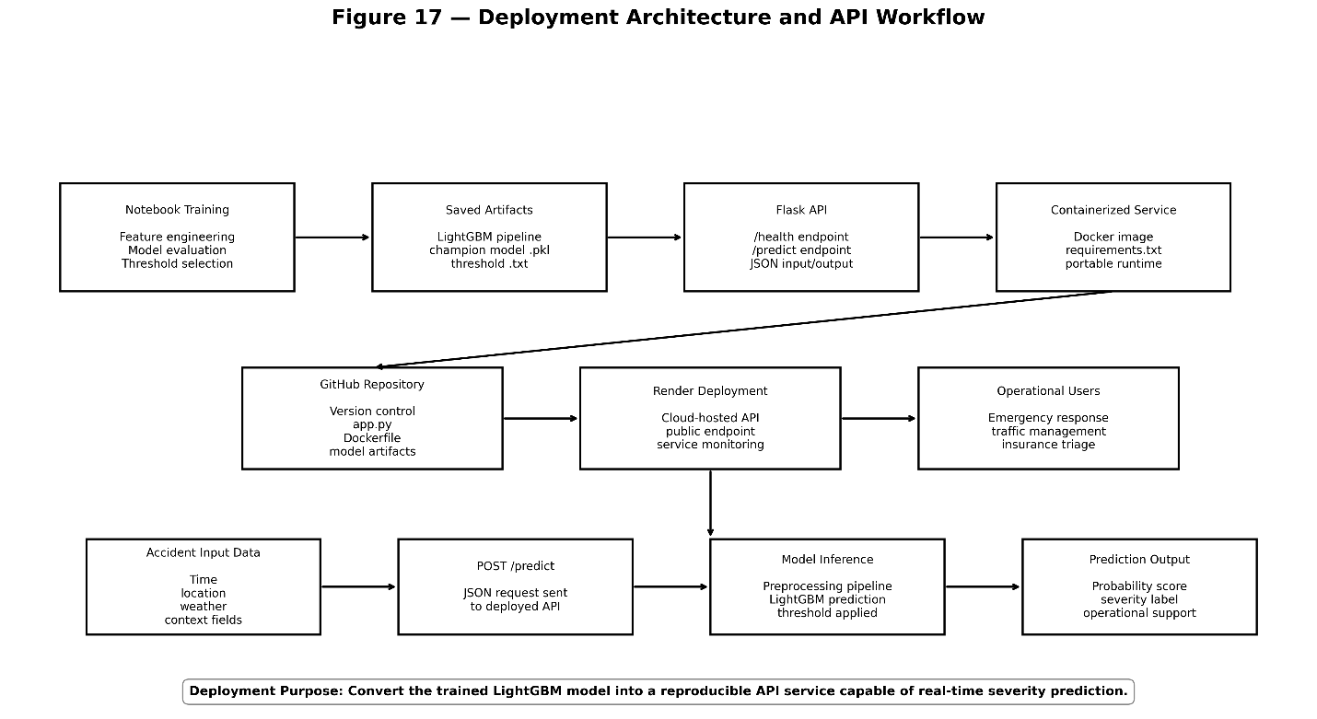

Limitations and Future Work
Despite strong overall predictive performance and operational generalization, several limitations remain that should be considered when evaluating the system’s real-world deployment readiness. Although the final LightGBM model demonstrated strong recall-oriented severity detection and high overall discrimination capability, the project was constrained by both dataset limitations and the absence of certain real-time operational data sources that could further improve predictive accuracy.
Data Limitations
One of the primary limitations of the project involved the absence of several potentially important real-time contextual features. The dataset did not directly capture driver behavior characteristics, live traffic congestion patterns, real-time weather feeds, roadway surface conditions, or dynamic routing information at the exact moment of accident occurrence. While engineered environmental proxies such as visibility and weather-related variables provided meaningful predictive signal, the absence of live operational context likely limited the model’s maximum achievable performance.
Additionally, some accident scenarios may have been influenced by highly localized or rapidly changing conditions that could not be fully represented within the static historical dataset structure. Although the model successfully captured broad temporal, environmental, and geographic severity patterns, real-time operational deployment would likely benefit from richer streaming contextual data capable of representing rapidly evolving roadway conditions.
False Positive Tradeoff
The recall-focused modeling strategy intentionally accepted elevated false-positive volume in order to minimize missed high-severity incidents. At the selected operating threshold, the final LightGBM model produced approximately 5,494 false positives and approximately 2,028 false negatives on the held-out test dataset. This tradeoff was considered operationally acceptable because the real-world consequences of failing to identify a severe accident were considered substantially more serious than generating additional precautionary alerts.
From an operational perspective, prioritizing recall reduced the probability of underestimating dangerous incidents and improved emergency response prioritization capability. However, elevated false-positive volume could potentially contribute to unnecessary escalation, excess alerting, or temporary over-allocation of response resources in large-scale deployment environments.
Data Drift and Operational Risk
Another important limitation involves the long-term stability of model behavior under changing transportation conditions. Traffic patterns, infrastructure quality, weather behavior, urban development, and driving habits evolve continuously over time. Without periodic retraining and monitoring, model calibration may gradually degrade, recall performance may decline, and regional traffic behavior may shift away from the patterns learned during training.
These forms of data drift represent an important operational risk for any deployed machine learning system operating in dynamic real-world environments. Continuous monitoring, performance validation, and retraining workflows would therefore be necessary to maintain long-term predictive reliability and operational effectiveness.
Future Improvements
Future work should focus on integrating richer real-time contextual information into the modeling pipeline, including live weather APIs, traffic congestion feeds, and dynamic roadway-condition data sources. Additional improvements could include automated retraining pipelines, drift-monitoring systems, expanded geographic granularity, ensemble calibration methods, and real-time streaming inference architectures capable of supporting large-scale operational deployment.
Further operational testing under production-like conditions would also improve deployment readiness by validating scalability, latency performance, monitoring workflows, and long-term system reliability. Collectively, these improvements would strengthen the model’s practical applicability and support transition from experimental development into a more mature operational decision-support platform.
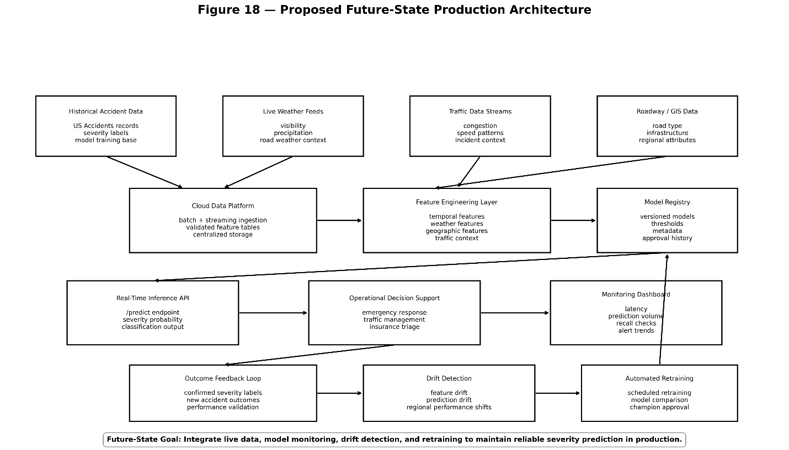

Ethical Considerations
This project involves several important ethical considerations because predictive systems operating within public safety environments can materially influence operational decision-making, emergency response prioritization, and resource allocation behavior. Although the model was developed primarily as a decision-support system, inaccurate or poorly calibrated predictions could still produce meaningful real-world consequences if deployed operationally without appropriate oversight and governance controls.
Resource Allocation Risk
One of the primary ethical concerns involves the potential impact of incorrect predictions on emergency response operations and transportation safety workflows. Misclassifications could potentially contribute to delayed emergency response, misallocation of personnel, over-prioritization of lower-risk incidents, or reduced operational efficiency. Because approximately 37 percent of observations belonged to the high-severity class, the model operated within a moderately imbalanced classification environment where prediction calibration and threshold selection were especially important.
The project therefore prioritized recall-oriented performance to minimize missed high-severity accidents, accepting a moderate increase in false positives in exchange for reducing the probability of underestimating dangerous incidents. While this tradeoff was considered operationally appropriate within a safety-critical environment, it also reinforced the importance of careful monitoring and validation during any future deployment scenario.
Geographic Bias Concerns
Another important ethical consideration involves the use of geographic and location-based variables within the modeling pipeline. Features such as state, city, time zone, and regional indicators may unintentionally function as proxies for socioeconomic status, infrastructure quality, regional inequality, or population density. As a result, there is a potential risk that certain geographic regions could systematically receive elevated predicted severity scores due to underlying structural or environmental disparities represented within the historical dataset.
These concerns highlight the importance of ongoing fairness evaluation, bias monitoring, and governance review during operational deployment. Geographic performance should therefore be continuously monitored to ensure that model behavior remains equitable and does not unintentionally reinforce existing transportation or infrastructure inequalities.
Privacy Considerations
Although the dataset did not contain direct personally identifiable information, geographic and temporal combinations can still create privacy concerns when aggregated at large scale. Transportation datasets containing detailed location and timing information may potentially allow indirect inference regarding movement patterns, roadway behavior, or regional activity concentrations if improperly managed.
Responsible deployment therefore requires strong data governance practices, controlled access management, aggregation safeguards, monitoring systems, and auditing procedures to reduce privacy risk and maintain appropriate operational oversight. Careful handling of location-based information would be particularly important in any future production deployment involving live transportation data streams or real-time operational integration.
Human Oversight
The model was intentionally designed to function as a decision-support system rather than a fully autonomous operational platform. Human judgment remains essential for emergency response prioritization, resource allocation, operational escalation, and incident interpretation, particularly in complex or ambiguous accident scenarios where contextual understanding extends beyond the information captured within the dataset.
For this reason, transparency and interpretability were prioritized throughout development using SHAP-based interpretability analysis and structured evaluation workflows. Maintaining human oversight helps ensure that machine learning predictions are used to support operational awareness and informed decision-making rather than replacing professional judgment within safety-critical environments.
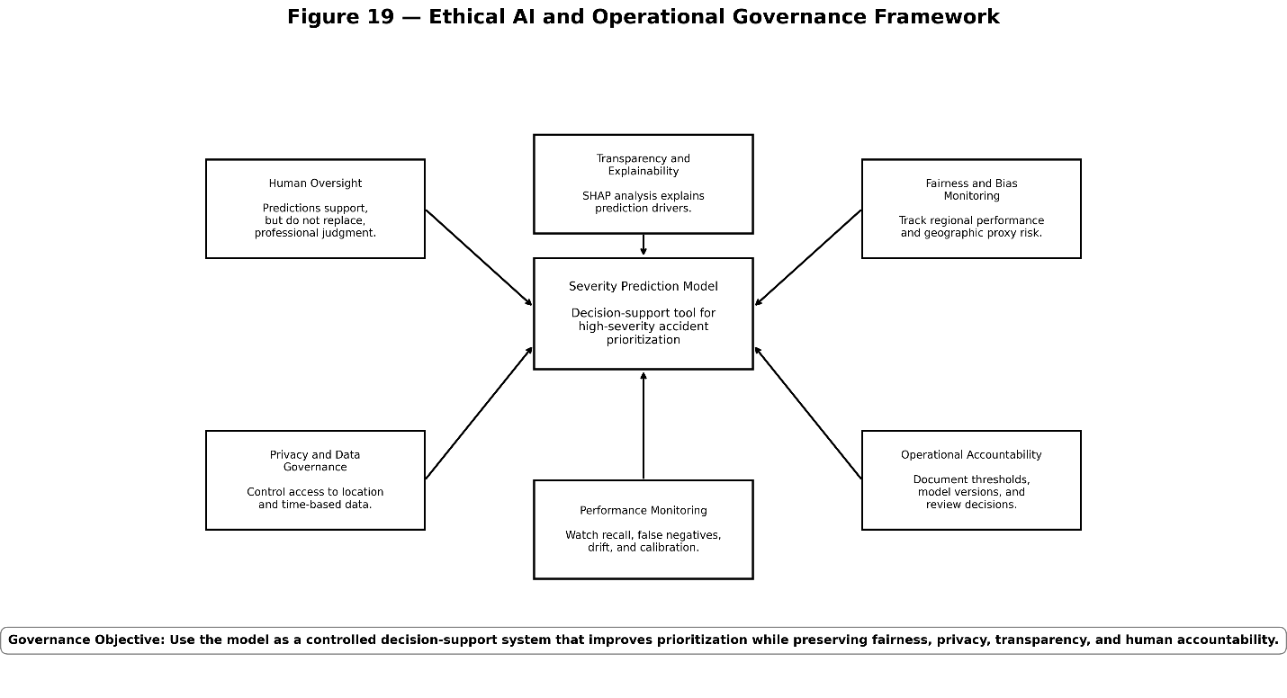
Conclusion
This project demonstrates that machine learning can effectively predict high-severity traffic accidents using structured spatiotemporal, environmental, and geographic data derived from large-scale transportation datasets. Through extensive preprocessing, feature engineering, exploratory analysis, and supervised model evaluation, the project successfully developed a predictive system capable of identifying high-severity accident scenarios with strong operational performance and meaningful real-world applicability.
Among all evaluated machine learning approaches, LightGBM emerged as the strongest-performing model. The final model achieved approximately 0.83 overall accuracy, 0.88 recall, 0.92 ROC-AUC, and 0.86 PR-AUC on the held-out test dataset. These results demonstrated strong classification capability under moderate class imbalance conditions while maintaining high recall for severe accident detection. Confusion matrix analysis further showed approximately 14,924 correctly identified high-severity accidents and only approximately 2,028 missed severe cases, directly supporting the project objective of minimizing false negatives in safety-critical operational environments.
A major strength of the project was the strong alignment between model outputs and real-world patterns identified during exploratory data analysis. Temporal traffic behavior, visibility conditions, weather-related factors, and geographic variation all contributed meaningful predictive signal throughout both model training and SHAP interpretability analysis. This consistency increased confidence in the model’s validity, interpretability, and operational reliability by demonstrating that the system learned meaningful real-world relationships rather than relying on arbitrary statistical correlations.
The completed system provides a strong foundation for practical deployment scenarios involving emergency response prioritization, transportation safety analysis, insurance risk triage, traffic management operations, and broader public safety planning. The integration of reproducible preprocessing pipelines, MLflow experiment tracking, containerized API deployment, and cloud-scalable architecture further demonstrated the project’s alignment with modern MLOps and operational machine learning practices.
Although the final model demonstrated strong overall performance, future improvements involving live weather integration, streaming traffic data, automated retraining pipelines, drift monitoring systems, and real-time inference architectures could further strengthen predictive capability and long-term operational readiness. Additional deployment testing under production-scale conditions would also improve scalability validation and reliability assessment.
Overall, the project demonstrates how machine learning can be operationalized into a scalable, interpretable, and practically useful decision-support system capable of supporting transportation safety operations and improving identification of high-severity accident scenarios in real-world environments.

References:
Chen, T., & Guestrin, C. (2016). XGBoost: A scalable tree boosting system. In Proceedings of the 22nd ACM SIGKDD International Conference on Knowledge Discovery and Data Mining (pp. 785–794). https://doi.org/10.1145/2939672.2939785
Jobin, A., Ienca, M., & Vayena, E. (2019). The global landscape of AI ethics guidelines. Nature Machine Intelligence, 1(9), 389–399. https://doi.org/10.1038/s42256-019-0088-2
Kaggle. (n.d.). Kaggle datasets documentation. https://www.kaggle.com/docs/datasets
Ke, G., Meng, Q., Finley, T., Wang, T., Chen, W., Ma, W., Ye, Q., & Liu, T.-Y. (2017). LightGBM: A highly efficient gradient boosting decision tree. In Advances in Neural Information Processing Systems (pp. 3146–3154).
Lundberg, S. M., & Lee, S.-I. (2017). A unified approach to interpreting model predictions. In Advances in Neural Information Processing Systems (pp. 4765–4774).
Moosavi, S., Samavatian, M. H., Parthasarathy, S., Ramnath, R., & Piorkowski, M. (2023). US accidents (2016–2023) [Data set]. Kaggle. https://www.kaggle.com/datasets/sobhanmoosavi/us-accidents
National Highway Traffic Safety Administration. (2023). Traffic safety facts annual report tables. U.S. Department of Transportation. https://www.nhtsa.gov/research-data/fatality-analysis-reporting-system-fars
Powers, D. M. W. (2011). Evaluation: From precision, recall and F-measure to ROC, informedness, markedness and correlation. Journal of Machine Learning Technologies, 2(1), 37–63.
Zaharia, M., Chen, A., Davidson, A., Ghodsi, A., Hong, S. A., Konwinski, A., Murching, S., Nykodym, T., Ogilvie, P., Parkhe, M., Xie, F., & Zumar, C. (2018). Accelerating the machine learning lifecycle with MLflow. IEEE Data Engineering Bulletin, 41(4), 39–45.

